OBJECTIVES:
- To write a program to perform calculations.

MATERIAL:
- Atmel Studio

WEB SITES:
- www.microchip.com for Atmel Studio Software

ACTIVITY 1
Write a program that calculates (PORTC + 4) * PORTD and sends out the result through PORTB. Consider all the values are unsigned.
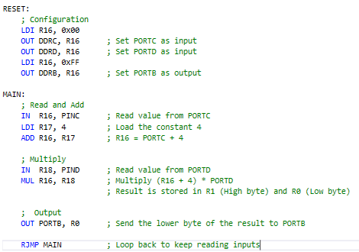

ACTIVITY 2
Write a program to calculate the result of (PORTB + PORTD)/2 and send out the result through PORTB. Consider all the values are unsigned. (Note: To divide by two, you can use shift right operation)
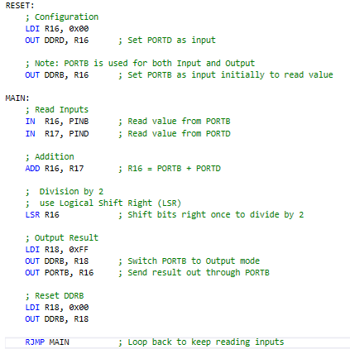

ACTIVITY 3
- Find the value in R0 and R1 after the following code. What are the values kept in R0 and R1?
LDI R16, 10 ; Load 10 into R16
LDI R17, 20 ; Load 20 into R17
LDI R18, 30 ; Load 30 into R18
MUL R16, R17 ; Multiply R16 * R17 (10 * 20 = 200)
ADD R0, R18 ; Add R18 to the result in R0 (200 + 30)
Final Values: R0 = 230 R1 = 0
- Find the value in R0 and R1 after the following code.What are the values kept in R0 and R1?
LDI R19, 19 ; Load 19 into R19
SUBI R19, 10 ; Subtract 10 from R19 (19 - 10 = 9)
LDI R30, 30 ; Load 30 into R30
MUL R30, R1 ; Multiply R30 * R19 (30 * 9 = 270)
Final Values: R0 = 14 R1 = 1
AVR hardware automatically splits multiplication results into R1 (High Byte) and R0 (Low Byte) to accommodate values larger than 255. For your $30 \times 9 = 270$ example, 270 is too big for one register, so R1 stores 1 (worth 256) and R0 stores 14, totaling 270

ACTIVITY 4
Write a program to add 10 bytes of data and store the result in registers R30 and R31. The bytes are stored in the Program memory starting at $200. The data would look as follows:
MYDATA: .DB 92,34,84,129,... ;pick your own data.
Note you must first bring the data from Program memory into the registers, then add them together. Use a simulator and single-step to examine the data.
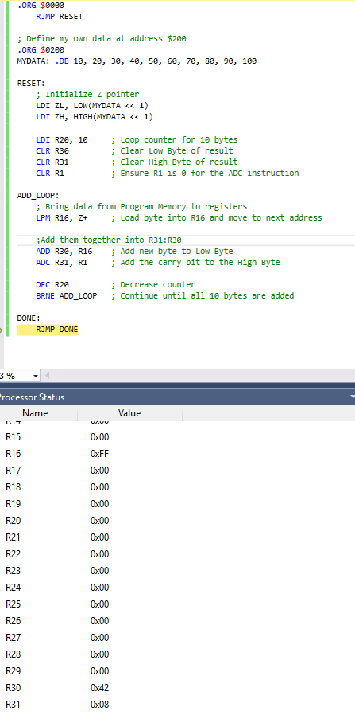

ACTIVITY 5
Write a program to add 10 bytes of Binary-Coded Decimal (BCD) data and store the result in R30 and R31. The bytes are stored in Program memory starting at $300. The data would look as follows:
MYDATA: .DB $92,$34,$84,$29,... ;pick your own data.
Note you must first bring the data from Program memory into the registers, then add them together. Use a simulator and single-step to examine the data.
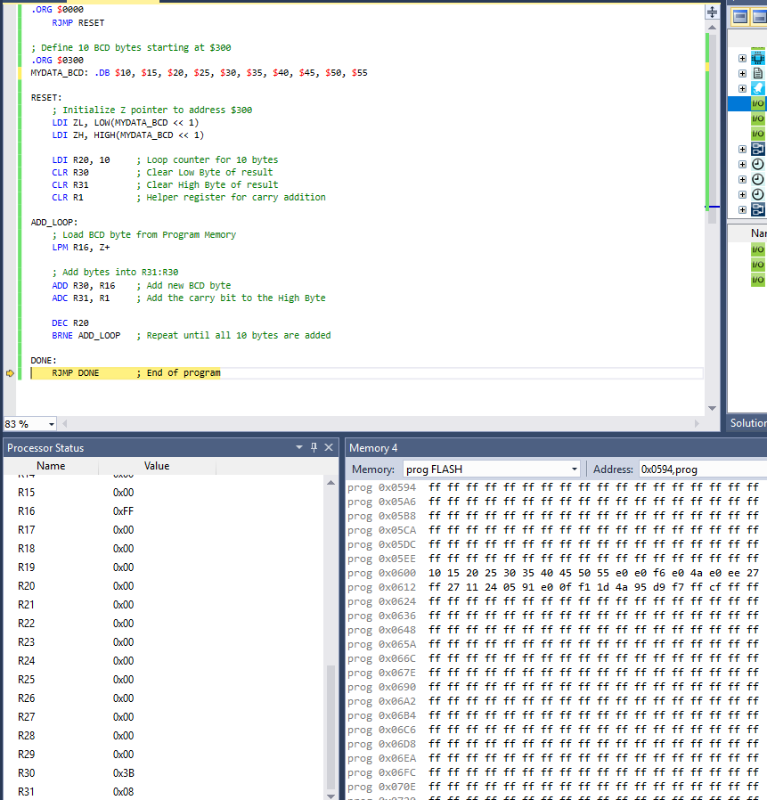

ACTIVITY 6
Write a program to add two BCD numbers and store the result in RAM location $100 - $104. The two multibyte items are stored in the program memory starting at $120 as following data.
.ORG $120
DATA_1: .DB $54,$76,$65,$98 ;number 0x98657654
DATA_2: .DB $93,$56,$77,$38 ;number 0x38775693
